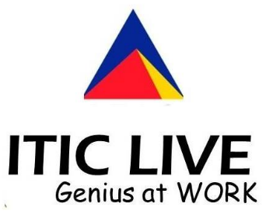

**Statement of Works for**

**The 2nd International Workshop on**

**AI-enabled Process Automation**

**November 22nd to 25th, ICSOC, Dubai, UAE**

**STATEMENT OF WORKS**

* **NAME OF EVENT AND EVENT DETAILS:**

Business processes are central to the operation of public and private enterprises. Today, the advancement in Service Oriented Computing, Artificial Intelligence (AI) and Data Science has the potential to transform business processes in fundamental ways; by assisting knowledge workers in communicating analysis findings, supporting pieces of evidence and to make decisions.  
  
The 2nd International Workshop on AI-enabled Process Automation (AI-PA) will be held as one of the workshops of the [19th International Conference on Service Oriented Computing](http://www.icsoc.org/) (ICSOC 2021). The AI-PA workshop aims at providing a forum for researchers and professionals interested in Artificial Intelligence (AI) enabled Business Processes and Services; and in understanding, envisioning and discussing the opportunities and challenges of intelligent Process Automation, Process Data Analytics and providing Cognitive Assistants for knowledge workers.

* **EVENT PROGRAM:**

<https://aip-research-center.github.io/AIPA_workshop/2021/>

* **Hosting Event Organisation Details:**

Macquarie University, Department of Computing

4 Research Park Drive, Macquarie University, NSW

* **Event Organiser**

Dr Amin Beheshti, Director of AI-enabled Processes (AIP) Research Centre, Department of Computing, Macquarie University

E: [amin.beheshti@mq.edu.au](mailto:amin.beheshti@mq.edu.au)

P: 02 9850 6344

* **Contact, ITIC, Australia**

Mr Stephen Elbourn, Director, ITIC

Level 3/321 Pitt St, Sydney NSW 2000

E: [stephen.elbourn@itic.com.au](mailto:stephen.elbourn@itic.com.au)

* **AGREED AMOUNT TO BE SPONSORED BY ENGENESIS AUSTRALIA**

$5,000.00AUD (exclude tax)

* **AGREED BENEFITS TO COMPANY ENGENESIS AUSTRALIA SPONSORING THE MACQUARIE UNIVERSITY HACKATHON (GOLD SPONSER)**

Benefits will include:

• Advance recognition as the main sponsor for the workshop website.

• Opportunity for the company to present itself in the Welcome Reception.

• One-page mono advertisement in the program booklet.

• Company logo on workshop bags.

• Company logo on workshop Website.

• Opportunity to Displayed banner.

• Complimentary registration for five company representatives for the workshop.

**Accepted for and on behalf of ITIC Australia**

Signed: ________________________________________

Name: ________________________________________

Title: ________________________________________

Date: ___________________________